LRRP/RANGER SONG
Written by
Dwight “Bull” Durham
Killed in action, April 10, 1969
Company H, 75th Rangers, 1st Cav Division
Sang to the tune “Ghost Riders in the Sky”

Gather `round you college kids a story I will tell of six brave Recondo men who spent their days in hell; with “16” at their shoulder and claymores in their pack, six men went out that day,
but only one came back.

Bully’s boys and weaklings, they all went out that day, a’ fighting old Charlie-Cong, the devil they had to pay; with “16” at their shoulder and claymores in their pack, six men went out that day, but only one came back.

Oh, Boggie had his courage, he knew he was the best, the weakling had a plastic cross he wore upon his chest. with “16” at their shoulder and claymores in their pack,
Six men went out that day, but only one came back.

Oh, Charlie knew they were there the minute they set down, they pulled upon a hill top and the gooks were all around. Six “16” were a blazing underneath the setting moon, but they all knew as sure as death, the reaper would come soon.

The LRRP’s thought they had it made the sun was in the sky, but about that time
old Charlie let a B40 fly. They heard it screaming through the air, a coming straight at them,
but they just stood their ground, those brave Recondo men.

The rifles they were silent and the blood was all around. five brave rangers lay dead upon the ground. The weakling stumbled to his knees and to the men he cried, “Why did you leave me here? Oh, God, please let me die!”

Charlie was a-coming up the hill to collect his gory pay, the weakling saw them coming and
Escape there was no way. With a “16” at his shoulder and a claymore to his front, he fought off Charlie Cong that day, for the team dead at his back.

But then he heard the sound, that sound he knew so well, the birds were coming for him, to take him from that hell. With trigger-finger slacking, and a tear in his eyes, B but it never fell for them, for rangers don’t cry.

So when they got him back to camp they said you need a rest;
He lowered his head, unbuttoned his shirt and there upon his chest, the plastic cross had melted, but he was still alive; the rocket had left its mark to remind him of those five.

Now you ask him to this day just what he did in “Nam” he’ll say he walked the jungle
and fought old Charlie Cong. With a “16” at the ready, and a claymore in my pack, six men went out that day, But only I came back

THE WALL
Written by
Royce Clark

On a cold black sheen of granite
To many to recall
Are the names and the dates, and the faces
Of the men upon the wall
These are the fallen warriors
These are the fallen warriors
The young, the old, the brave
Who gave their last full measure
To a land, a cause, to a grave
On a cold black sheen of granite
Too many to recall
Are the names and the dates, and the faces
Of the men upon the wall
These are the fallen warriors
The young, the old, the brave
Who gave their last full measure
To a land, a cause, to a grave
Each had an unfinished story
Each had a song left to sing
Now all that remains are the memories
That fade like a winter to a spring
at night when the world falls quiet
and the orb in the sky grows cold
The sprits of the Wall talk freely
And eminence of the days long ago
Aging years have passed since the struggle
Youth has run far away
But the Wall and the cries of battle
Return like the sunrise each day
And the last flag drapes the last grave
The Lord up above will say, “Welcome home”
And the Wall will at last fade away

JUST A COMMON SOLDIER
(A Soldier Died Today) written by
A. Lawrence Vaincourt
(not a 1st Cav Ranger)

He was getting old and paunchy and his hair
was falling fast, and he sat around the Legion, telling
story of the past. Of a war that he had fought in and
the deeds that he had done. In his exploits with his
buddies, they were hero’s, everyone.
And tho’ sometimes, to his neighbors, his tales
became a joke, all his Legion buddies listened,
for they knew whereof he spoke. But we will hear
his tales no longer for old Bill has passed away,

He will not be mourned by many, just his children and
his wife, for he lived an ordinary and quite uneventful
life. Held a job and raised a family, quietly going his
own way, and the world won’t note his passing, though
a soldier died today.

When politicians leave this earth, their bodies lie in
state, while thousands note their passing and proclaim
they were great. Papers tell their whole life stories,
from the time that they were young. But the passing of
soldier goes unnoticed and unsung.

Is the greatest contribution to the welfare of our land
A guy who breaks his promises and cons his fellow
man? Or the ordinary fellow, who and times of war and
strife, goes off to serve his country and offers up his
A politician’s stipend and the style in which he lives
are sometimes disproportionate to the service that he gives.
While the ordinary soldier, who offers up his all,
is paid off with a medal and perhaps, a small pension.

ARNOLD, DANIEL RAYMOND SP4 BANTA, MICHAEL DEAN PFC
HONORED ON PANEL: 25W LINE: 93 HONORED ON PANEL: 7W LINE: 105
DATE OF BIRTH: APRIL 22, 1948 DATE OF BIRTH: OCTOBER 5, 1949
DATE OF CASUALTY: MAY 13, 1969 DATE OF CASUALTY: OCTOBER 2, 1970
FROM: FROSTPROOF, ARIZONA FROM: CORDOVE- VALDEZ, ARKANSAS
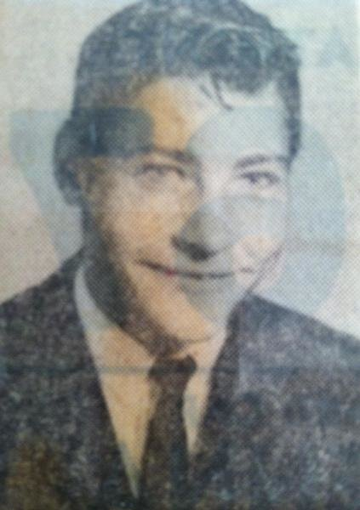
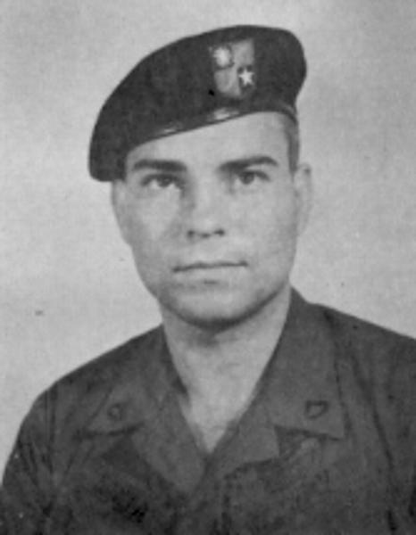

https://www.vvmf.org/Wall-of-Faces/search/results/?search-term=arnold+daniel+raymond/
https://www.vvmf.org/Wall-of-Faces/search/results/?search-term=banta+michaeL/

BELL, WILLIAM BRENT LT BURCH, KENNETH EUGENE SGT

HONORED ON PANEL: 28W LINE: 57 HONORED ON PANEL: 20W LINE: 128
DATE OF BIRTH: SEPTEMBER 7, 1943 DATE OF BIRTH: NOVEMBER 4, 1950
DATE OF CASUALTY: MARCH 27, 1969 DATE OF CASUALTY: AUGUST 11, 1969
FROM: ESSEX FELLS, NEW JERSEY FROM: CATAULA, GEORGIA
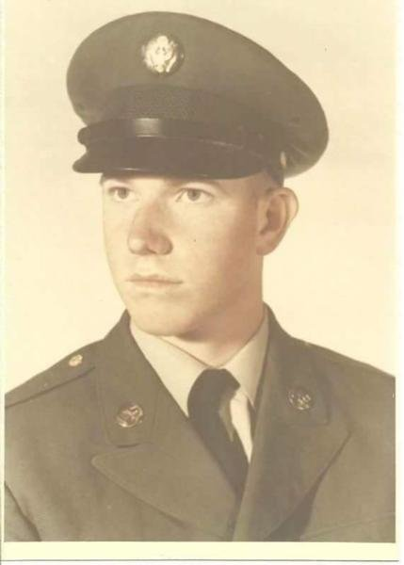
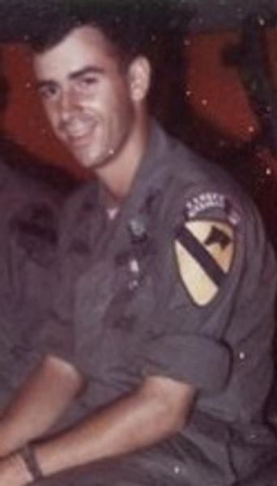

https://www.vvmf.org/Wall-of-Faces/3406/WILLIAM-B-BELL/
https://www.vvmf.org/Wall-of-Faces/6734/KENNETH-E-BURCH/

CARSON, OMER PRICE SGT COCHRANE, DEVERTONCARPENTER SFC
HONORED ON PANEL: 6W LINE: 112 HONORED ON PANEL: 9W LINE: 59
DATE OF BIRTH: DECEMBER 21, 1951 DATE OF BIRTH: DECEMBER 15, 1948
DATE OF CASUALTY: DECEMBER 7, 1970 DATE OF CASUALTY: JUNE 17, 1970
FROM: CAMPTON, KENTUCY FROM: BROOKLINE, MAINE
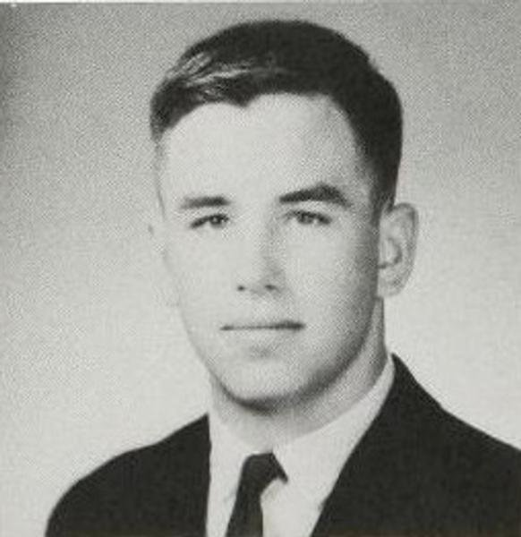
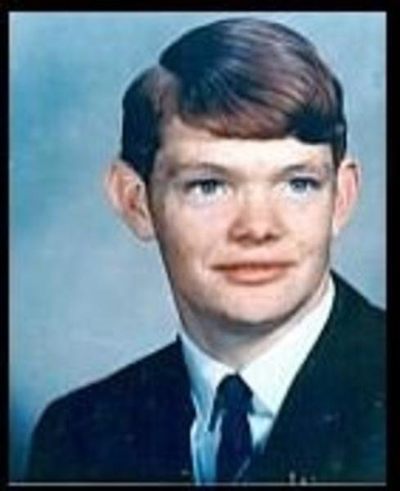

https://www.vvmf.org/Wall-of-Faces/8129/OMER-P-CARSON/
https://www.vvmf.org/Wall-of-Faces/9625/DEVERTON-C-COCHRANE/

CRITCHFIELD, WILLIAM ROBERT SP4 DICKINSON, DAVID THOMAS SGT

HONORED ON PANEL: 32E LINE: 71 HONORED ON PANEL: 31E LINE :45
DATE OF BIRTH: FEBUARY 6, 1947 DATE OF BIRTH: FEBUARY 2, 1948
DATE OF CASUALTY: DECEMBER 27, 1967 DATE OF CASUALTY: DECEMBER 6, 1969
FROM: MAPLE SHADE, NEW JERSEY FROM: DENVER, COLORADO
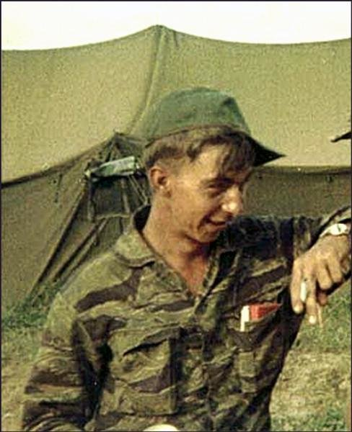
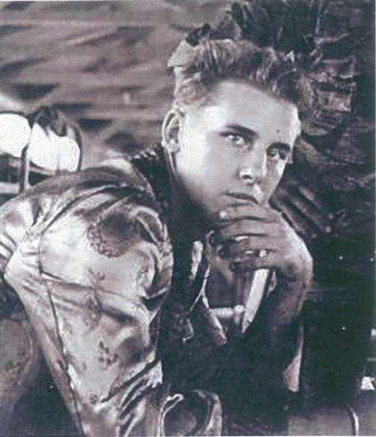

https://www.vvmf.org/Wall-of-Faces/11132/WILLIAM-R-CRITCHFIELD/
https://www.vvmf.org/Wall-of-Faces/13250/DAVID-T-DICKINSON/

DURHAM, DWIGHT MONTGOMERY SGT ELIAS, JUAN ANGEL SGT

HONORED ON PANEL: 27W LINE: 48 HONORED ON PANEL: 63W, LINE: 5
DATE OF BIRTH: AUGUST 23, 1949 DATE OF BIRTH: OCTOBER 12, 1945
DATE OF CASUALTY: APRIL 10, 1969 DATE OF CASUALTY: MAY 29, 1968
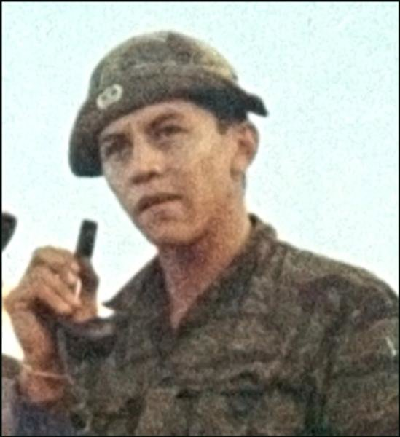
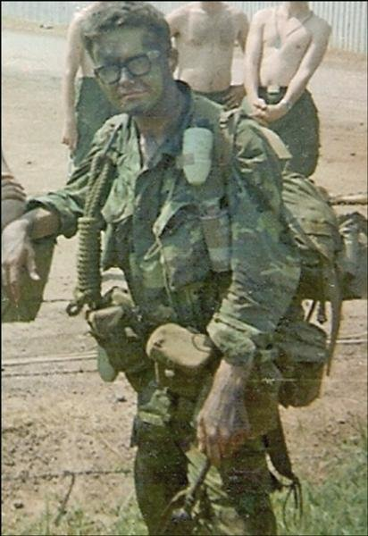
FROM: TULSA, OKLAHOMA FROM: TUCSON, ARIZONA

https://www.vvmf.org/Wall-of-Faces/14323/DWIGHT-M-DURHAM/
https://www.vvmf.org/Wall-of-Faces/14830/JUAN-A-ELIAS/

GRIFFITH, TONY LEE SGT HARPER, TIMOTHY VAUGHN SSGT

HONORED ON PANEL: 33W LINE: 63 HONORED ON PANEL: 5W LINE: 113
DATE OF BIRTH: FEBUARY 20, 1948 DATE OF BIRTH: OCTOBER 14, 1950
DATE OF CASUALTY: FEBUARY 5, 1969 DATE OF CASUALTY: FEBUARY 17, 1971
FROM: BUTLER, TENNESSE FROM: CEYLON, MINNESOTA
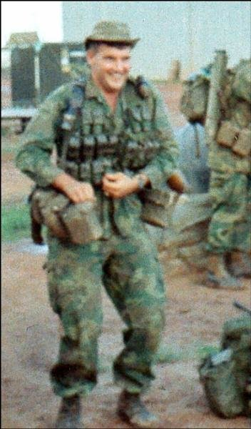
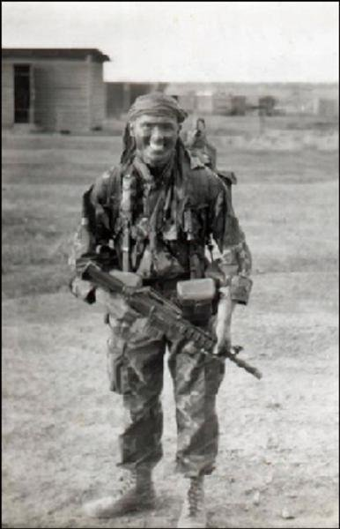

https://www.vvmf.org/Wall-of-Faces/20100/TONY-L-GRIFFITH/
https://www.vvmf.org/Wall-of-Faces/21471/TIMOTHY-V-HARPER/
HOLUPKO, LON MICHAEL SP4 IVES, DAVID ALLEN SP4

HONORED ON PANEL: 21W LINE: 93 HONORED ON PANEL: 18E LINE: 75
DATE OF BIRTH: OCTOBER 16, 1948 DATE OF BIRTH: AUGUST 12, 1946
DATE OF CASUALTY: JULY 10, 1969 DATE OF CASUALTY: APRIL 23, 1967
FROM: DETROIT, MINNESOTA FROM: FAIRFIELD, CALIFORNIA

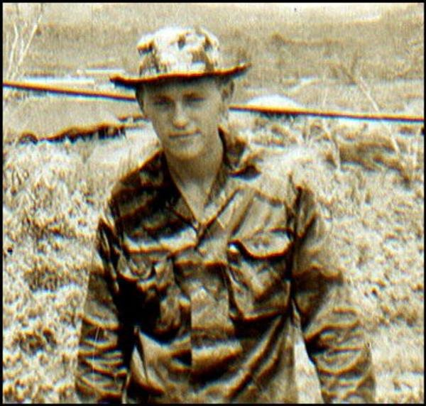
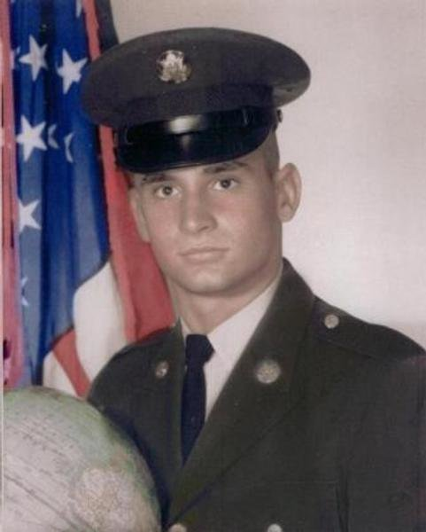

https://www.vvmf.org/Wall-of-Faces/23929/LON-M-HOLUPKO/
https://www.vvmf.org/Wall-of-Faces/25191/DAVID-A-IVES/

LAKER, CARL JOHN SP4 LAMBERT, WILLIAM GLENN SGT

HONORED ON PANEL: 9W LINE: 60 HONORED ON PANEL: 51E LINE: 8
DATE OF BIRTH: JUNE 12, 1950 DATE OF BIRTH: MAY 25, 1947
DATE OF CASUALTY: JUNE 17, 1970 DATE OF CASUALTY: APRIL 20, 1968
FROM: CLEARWATER, FLORDIA FROM: PENSACOLA, FLORIDA

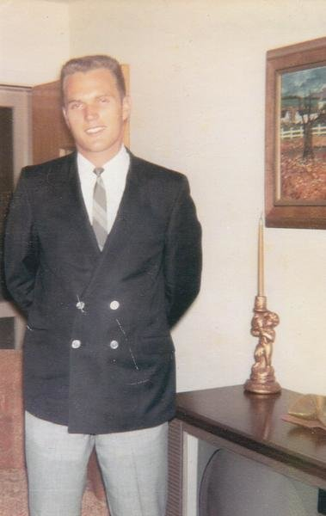
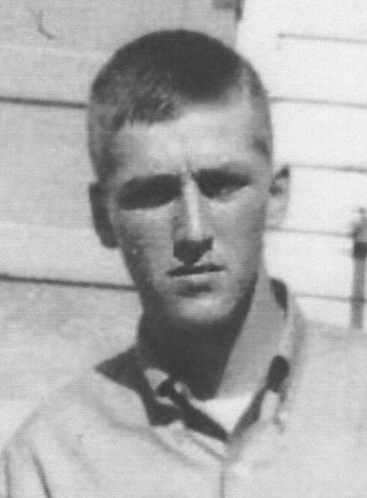

https://www.vvmf.org/Wall-of-Faces/29370/CARL-J-LAKER/
https://www.vvmf.org/Wall-of-Faces/29429/WILLIAM-G-LAMBERT/

LARGENT, LOEL FLOYD SGT LENTO, STANLEY JOHN, SGT
PANEL: 27W LINE: 52 PANEL 20W LINE 40
DATE OF BIRTH: MARCH 13, 1950 DATE OF BIRTH: JANUARY 19, 1949
CASUALTY ON: APRIL 10, 1969 CASUALTY ON: 24/07/1969
FROM: RUSK, TX FROM: BLAINE, MAINE

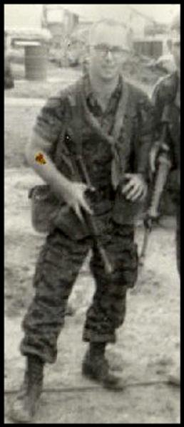
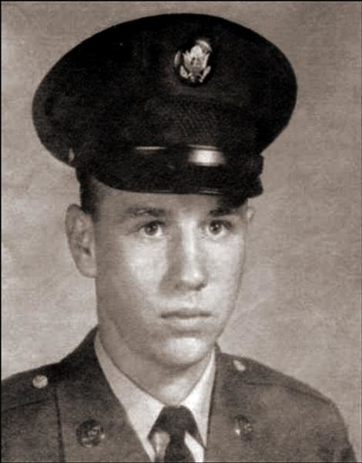

https://www.vvmf.org/Wall-of-Faces/29692/LOEL-F-LARGENT/
https://www.vvmf.org/Wall-of-Faces/30373/STANLEY-J-LENTO/

LEON, FELIX JR, PFC MAURER, JEFFERY ALAN, SP4

PANEL: 45E LINE: 12 PANEL: 1W LINE: 39
DATE OF BIRTH: JUNE 6, 1948 DATE OF BIRTH: MAY 1, 1953
CASUALTY ON: MARCH 17, 1968 CASUALTY ON: JUNE 9, 1972
FROM: RIO PIEDRAS, PUERTO RICO FROM: NEW LIBERTY, IOWA

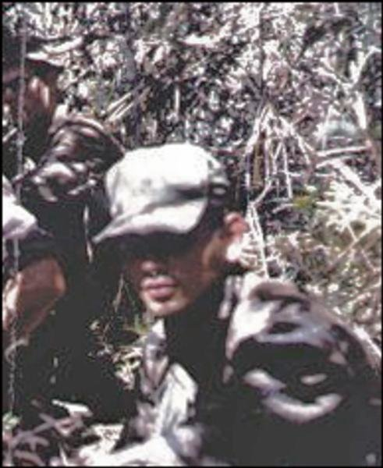
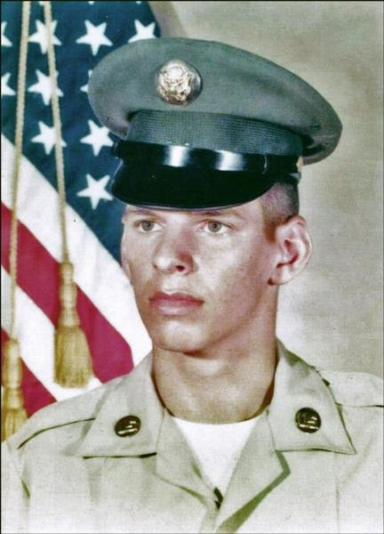

https://www.vvmf.org/Wall-of-Faces/search/results/?search-term=FELIX+LEON/
https://www.vvmf.org/Wall-of-Faces/search/results/?search-term=JEFFERY+MAURER/

MCCARTHY, CARL RICHARD SP4 MCCONNELL, GERALD WAYNE JR, SP4

PANEL: 7W LINE: 78 PANEL: 57E LINE: 7
DATE OF BIRTH: MAY 06, 1950 DATE OF BIRTH: APRIL 24, 1947
CASUALTY ON: SEPTEMBER 20, 1970 CASUALTY ON: MAY 8, 1968
FROM ROCHESTER, NEW YORK FROM: MOSES LAKE, WASHINGTON

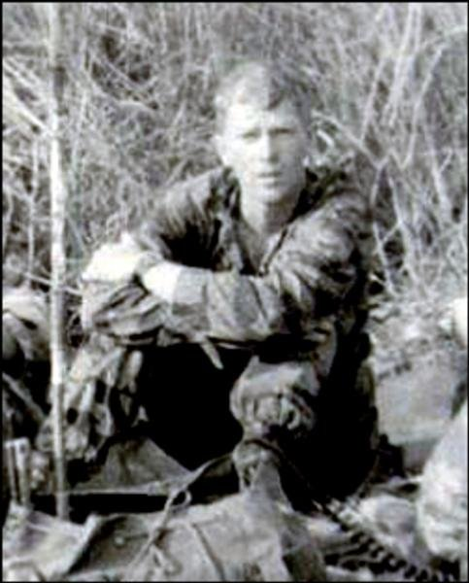
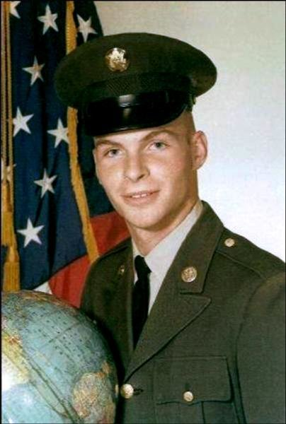

https://www.vvmf.org/Wall-of-Faces/36151/BRIAN-E-MCCARTHY/
https://www.vvmf.org/Wall-of-Faces/search/results/?search-term=GERALD+MCCONNELL/

MCDANIEL, ARCHIE HUGH JR, CPL MCDERMOTT, LEWIS E, MSGT

PANEL: 20W LINE: 41 PANEL: 27E LINE: 38
DATE OF BIRTH: JUNE 9, 1950 DATE OF BIRTH: AUGUST 5, 1932
CASUALTY ON: JULY 24, 1969 CASUALTY ON: DECEMBER 6, 1967
FROM: KIRKLAND, WASHINGTON FROM: FULTON, MONTANA

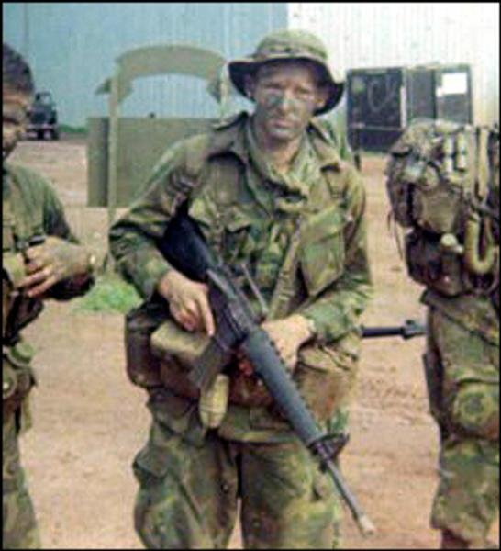
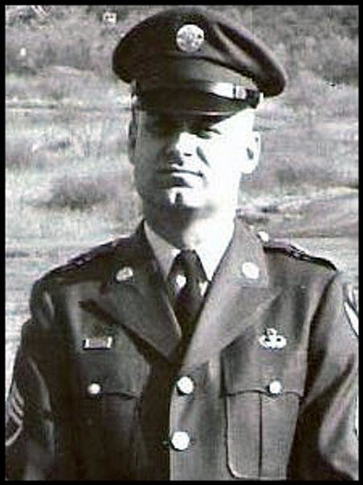

https://www.vvmf.org/Wall-of-Faces/search/results/?search-term=ARCHIE+MCDANIEL/
https://www.vvmf.org/Wall-of-Faces/search/results/?search-term=LEWIS+MCDERMOTT/

MILLER, DONALD, CPL NOTO, ROBERT JOSEPH, PFC

PANEL: 64E LINE: 11 PANEL: 51E LINE: 11
DATE OF BIRTH: NOVEMBER 21, 1947 DATE OF BIRTH: JANUARY 20, 1948
CASUALTY ON: MAY 21, 1968 CASUALTY ON: APRIL 20, 1968
FROM: POMPTON LAKE, NEW JERSEY FROM: ST LOUIS, MISSOURI

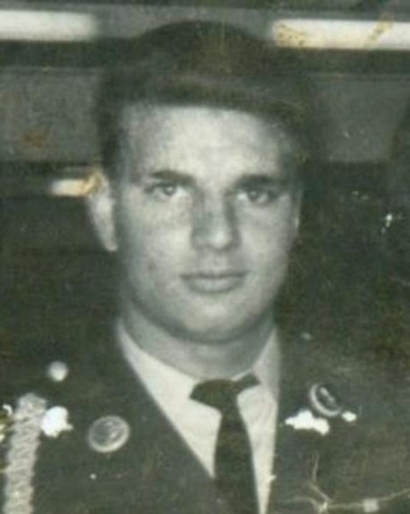
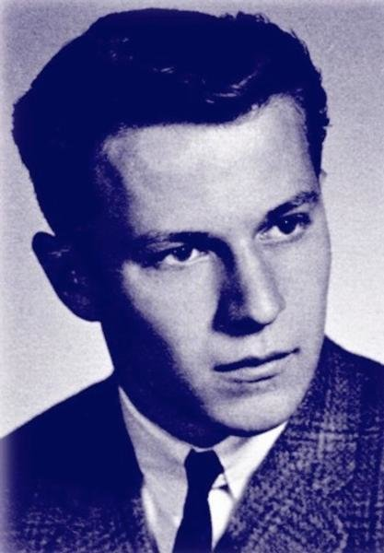

https://www.vvmf.org/Wall-of-Faces/search/results/?search-term=DONALD+MILLER/
https://www.vvmf.org/Wall-of-Faces/search/results/?search-term=ROBERT+NOTO/

OSBORNE, ELVIS WELDON JR, SGT PACHECO, JAIME, SP4

PANEL: 1W LINE: 39 PANEL: 1W LINE: 32
DATE OF BIRTH: OCTOBER 19, 1951 DATE OF BIRTH: MARCH 1, 1952
CASUALTY ON: JUNE 9, 1972 CASUALTY ON: MAY 25, 1972
FROM: DALLAS, TEXAS FROM: HOBBS, NEW MEXICO

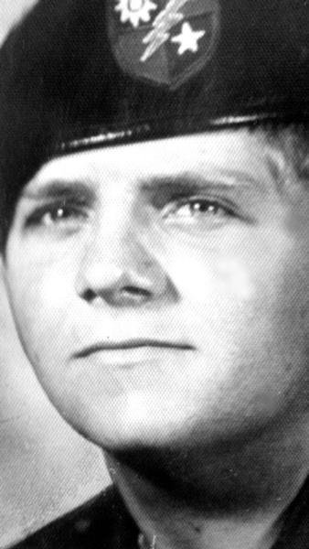
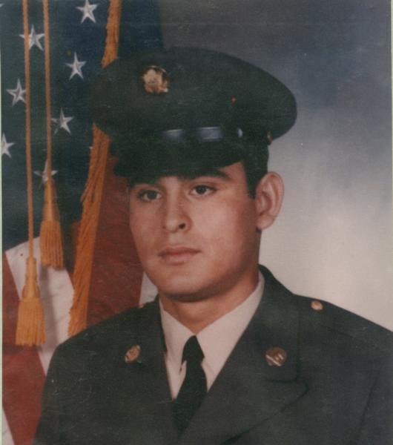

https://www.vvmf.org/Wall-of-Faces/search/results/?search-term=ELVIS+OSBORNE/
https://www.vvmf.org/Wall-of-Faces/search/results/?search-term=JAIME+PACHECO/
SALMINEN, PAUL JOHN, SGT SHEEHAN, DANIEL MORELAND, SP4

PANEL: 20W LINE: 41 PANEL: 20W LINE: 12
DATE OF BIRTH: NOVEMBER 23, 1943 DATE OF BIRTH: JULY 31, 1949
CASUALTY ON: JULY 24, 1969 CASUALTY ON: JULY 17, 1969
FROM: FERNDALE, MICHIGAN FROM: AURORA, COLORADO
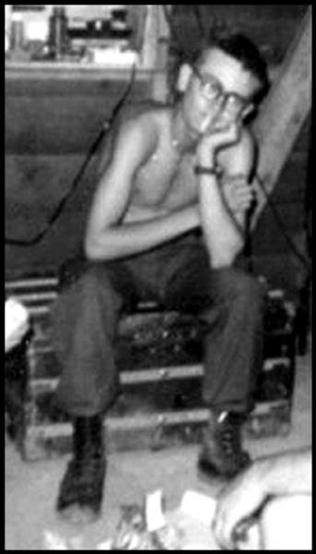
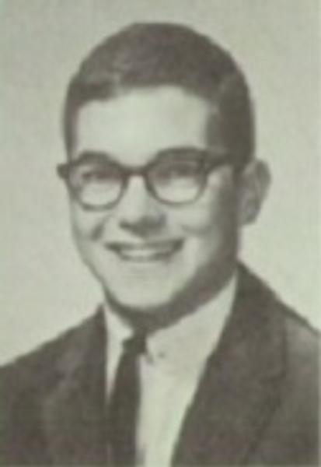

https://www.vvmf.org/Wall-of-Faces/search/results/?search-term=PAUL+SALMINEN/
https://www.vvmf.org/Wall-of-Faces/search/results/?search-term=DANIEL+SHEEHAN/

SMITH, THOMAS EMINGS SP4 SPRINKLE, THOMAS THOMA SP4

PANEL: 2W LINE: 108 PANEL: 53W LINE: 40
DATE OF BIRTH: JUNE 27, 1952 DATE OF BIRTH: SEPTEMBER 25, 1946
CASUALTY ON: FEBRUARY 20, 1972 CASUALTY ON: JULY 7, 1968
FROM: EVART, MINNESOTA FROM: MECHANICSBURG, PA

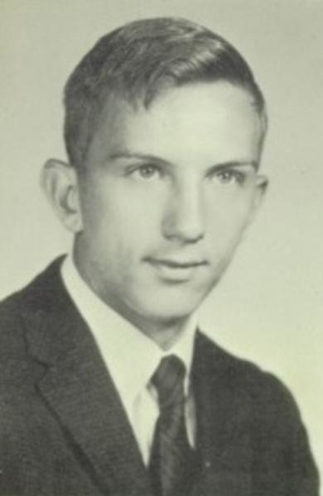
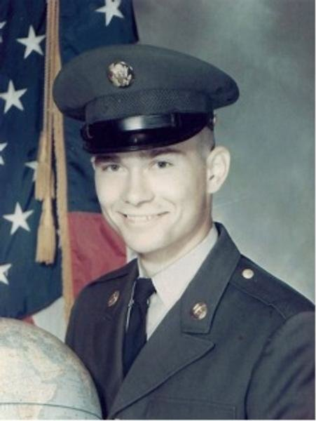

https://www.vvmf.org/Wall-of-Faces/48609/THOMAS-E-SMITH/
https://www.vvmf.org/Wall-of-Faces/49272/THOMAS-T-SPRINKLE/

TORRES, DAVID, SP4 TUCKER, DAVID BRUCE, MAJ
PANEL: 16W LINE: 91 PANEL: 27E LINE: 38
DATE OF BIRTH: AUGUST 21, 1946 DATE OF BIRTH: FEBUARY 15, 1939
CASUALTY ON: NOVEMBER 17, 1969 CASUALTY ON: OCTOBER 1, 1967
FROM: LOS ANGLES, CALIFORNIA FROM: ELMHURST, NEW YORK
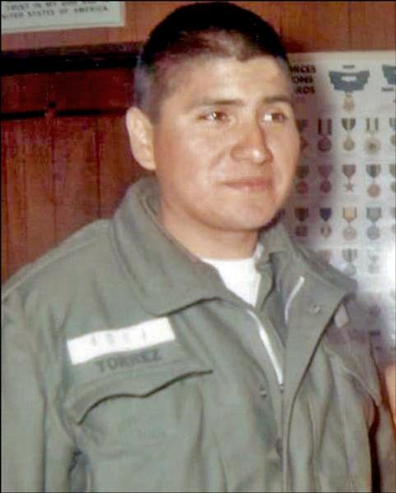
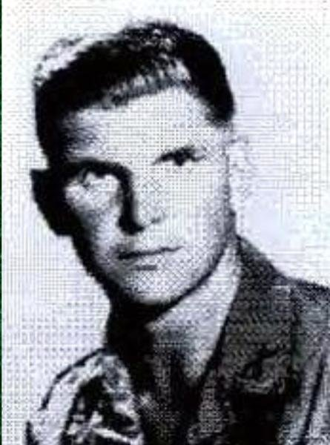

https://www.vvmf.org/Wall-of-Faces/search/results/?search-term=DAVID+TORRES/
https://www.vvmf.org/Wall-of-Faces/search/results/?search-term=DAVID+BRUCE+TUCKER/

TURBITT, RICHARD JOHN JR, SP4 WHITTEN, ROBERT EUGENE, SGT

PANEL: 51E LINE: 14 PANEL: 57E LINE: 12
DATE OF BIRTH: APRIL 20, 1948 DATE OF BIRTH: JANUARY 27, 1947
CASUALTY ON: APRIL 20, 1968 CASUALTY ON: MAY 8, 1968
FROM: WAUKEGAN, ILLINOS FROM: FT. MYERS, FLORDA

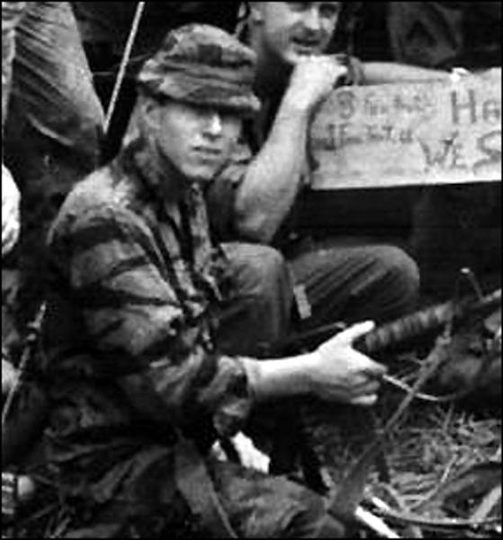
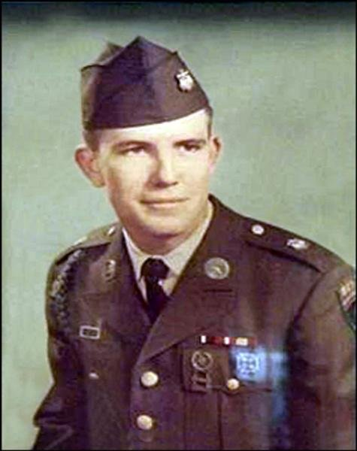

https://www.vvmf.org/Wall-of-Faces/search/results/?search-term=RICHARD+JOHN+TURBITT/
https://www.vvmf.org/Wall-of-Faces/search/results/?search-term=ROBERT+EUGENE+WHITTEN/
WILLIAMS, JOHN CHARLES, SP4 ZAPOROZEC, JULIUS, SP4

PANEL: 19W LINE: 6 PANEL: 16W LINE: 91
DATE OF BIRTH: MARCH 26, 1948 DATE OF BIRTH: OCTOBER 14, 1948
CASUALTY ON: AUGUST 11, 1969 CASUALTY ON: NOVEMBER 17, 1969
FROM: SHAWNEE, KANSAS FROM: HACKETTSTOWN, NEW JERSEY

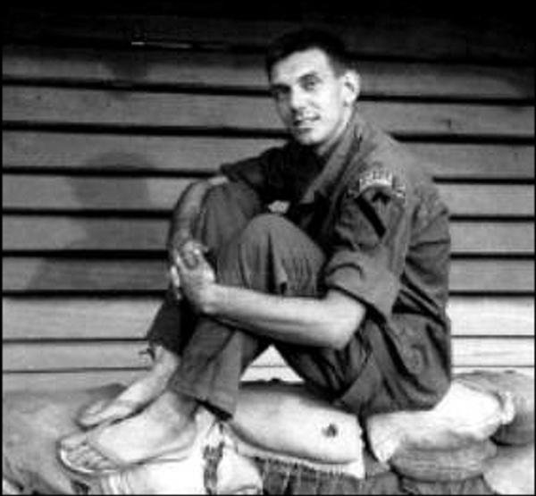
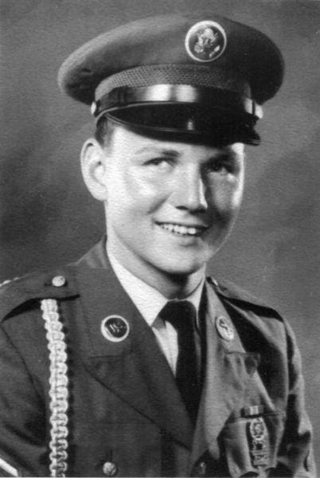

https://www.vvmf.org/Wall-of-Faces/56309/JOHN-C-Williams/
https://www.vvmf.org/Wall-of-Faces/57991/JULIUS-ZAPOROZEC/

